Zonta Club of Houston Educational & Charitable Fund (ZCHECF)

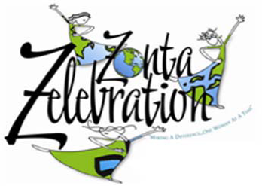
Annual Charity Clay Sport Shooting Event

Sat. February 8, 2020
Registration: 9:00am
Event Start Time: 10:00am

Location: American Shooting Center
16500 Westheimer Parkway, Houston, TX 77082
Cost is $130 per person or $600 for a team of 5 and includes 50 targets at a reserved private 10-station course (shooter shoots alternate 6/4 targets at each of the 10 stations). Non –Shooter Lunch is $25.00 per person.
Also Included:
    - Ammo- appropriate 12 gauge or 20 gauge
    - Eye & ear protection - yours to keep afterwards
    - Range officer- one per group/team of five
    - Scoring & computerized printout of scores
    - Loaner guns available at no cost (or you may bring your own)
    - Light Breakfast Snacks provided before the tournament
    - Lunch and Adult Liquid Refreshments following the shoot
    - Awards and gifts for the best scoringTeams and best Male & Female Shooters
    - Lots of Door Prizes
    - Additional Games and Mulligans available for purchase
    - Silent Auction
Supporter Signs: $100 to $400 each. Underwriter Sponsorships Available: $500 to $5,000 or any amount in between. Show your support of the Zonta mission by purchasing a Supporter or Underwriter Sign. These signs will be displayed at the stations and during the Awards Luncheon.
Sporting Clays is an exciting form of clay pigeon shooting, commonly described as “golf with a shotgun”. It involves shooting clay targets at multiple locations (called stations). The original idea behind sporting clays was to create an experience that more closely reflects actual hunting conditions. This allows for all generations to share in the experience. Please join us.

ZCHECF is a 501c(3) non profit organization. Proceeds from this event will benefit local Zonta scholarships for young women in high school and university level, as well as local and international service projects. Please visit www.zonta.org and www.zontahouston.org for more information. Thank you for your support.

For more information, please contact Kayleen Kill 713-851-7349 or kayleenkill@att.net

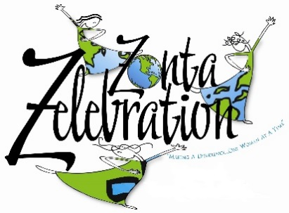
Annual Charity Clay Sport Shooting Event
Sat. February 8, 2020

REGISTRATION FORM

YES, I want to support Zonta Club of Houston Educational and Charitable Fund’s (ZCHECF) Sport Clay Shooting Event:

Name:______________________________ ___ # Of Individual Shooters @ $130

Address:____________________________ ___ # Of Teams -Five Shooters@ $600

City: ______________________ St: _____ Zip: ________________

Email Address: ______________________ ___ # Of Non-Shooter Lunches @ $25 ea.

Phone: _____________________________ ___ # Of Supporter Signs @ $_________

___ Count me in for an Underwriter Sponsorship for $__________ (enter amount)

My check payable to ZCHECF is enclosed

Please Charge my AMEX MC VISA DISCOVER

Acct #__________________________________

Exp Date _________ Validation Code _____

If Name on card or Billing address is different from above:

Name:_______________________________________________________

Address:______________________________________________________

City: ______________________ St: _____ Zip: ________________

Mail Registration to : Zonta Club of Houston Educational and Charitable Fund (ZCHECF)
c/o Kayleen Kill
12410 Shadow Island Dr
Houston, Texas 77082
713-851-7349

